**DAILY ONLINE ACTIVITIES SUMMARY**

|  |  |  |  |  |  |  |  |  |
| --- | --- | --- | --- | --- | --- | --- | --- | --- |
| **Date:** | **31st may,2020** | | | | | **Name:** | **Prathusha K A** | |
| **Sem & Sec** | **4th sem &b section** | | | | | **USN:** | **4AL18CS061** | |
| **Online Test Summary** | | | | | | | | |
| **Subject** | | **-** | | | | | | |
| **Max. Marks** | | **-** | | **Score** | | | **-** | |
| **Certification Course Summary** | | | | | | | | |
| **Course** | **Programming for everybody (getting started with python)** | | | | | | | |
| **Certificate Provider** | | | **Coursera** | | **Duration** | | | **7 weeks** |
| **Coding Challenges** | | | | | | | | |
| **Problem Statement: Problem Statement: Input : Read a String (combination of character, numeric, special character) from keyboard. Ex: #HaaGs01fOr@haaks07 Output : Upper case letters : 5 Lower case letters : 8 Numbers : 4 Special Characters : 2** | | | | | | | | |
| **Status: done** | | | | | | | | |
| **Uploaded the report in Github** | | | | | **yes** | | | |
| **If yes Repository name** | | | | | **https://github.com/prathu47/lockdown-coding** | | | |
| **Uploaded the report in slack** | | | | | **yes** | | | |

Certification Course Details: (Attach the snapshot and briefly write the report for the same)

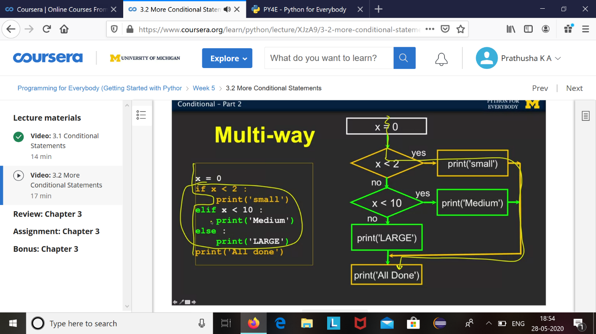

The course I have chosen during the lockdown period is programming for everybody. Since I had previously knew few topics about python iam continuing this course. Since python is gaining a lot of interest in coding platform I have preferred to choose this course.

Coding Challenges Details: (Attach the snapshot and briefly write the report for the same)

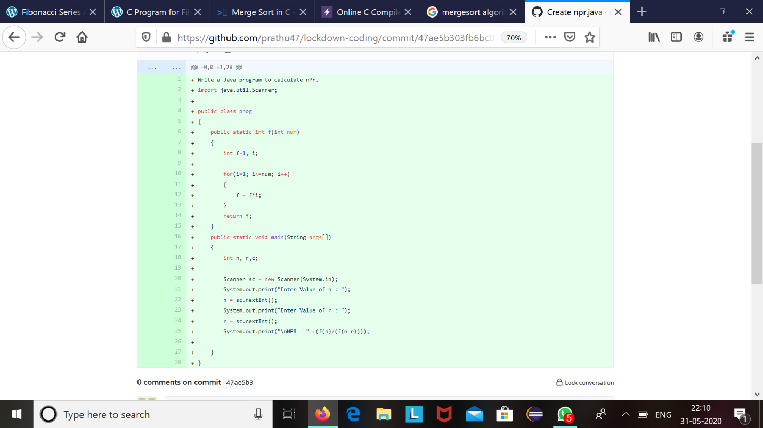

The question we had received today was :

Input : Read a String (combination of character, numeric, special character) from keyboard.

Ex: #HaaGs01fOr@haaks07

Output :

Upper case letters : 5

Lower case letters : 8

Numbers : 4

Special Characters : 2

Code:The above snapshot is the code which I have uploaded in my github repository.